Netscapes report

Gintare, Stephanie, Chris

**Tuesday 23rd January 2018, by 15:00**

A zip file that includes:  A ~1000-word report (.docx)

Introduction

Introduction (general overview of this project, hypothesis or questions that were created at the beginning of the project – Why is this work important? What are you trying to achieve? Aims and objectives). [100 - 150 words]

Our early ideas were to explore a visualisation of how each human impacted on the environment but through exploring different aspects of that idea we wanted to show how people impact on their environment as a persona.

The practical aim of the project was to externalise, through simple data visualisation, an individual users personality using the five factor model of personality traits . This would be interactive and immersive, allowing an individual user to input their own data and effect the outcome of the live visualisation. We wanted to offer an artistic representation of the data as well as using different methods of realisations. The hope of the project was to stimulate discussion on how others see our personality and what questions that might cause to arise.

Background

Background (all related references that have inspired this work, or any philosophical, theoretical, or practical context that this development is on. Include at least 5 references here) [300 words]

Our early research into finding a suitable model of the human condition began by exploring Maslow's Hierarchy of Needs and how we could derive data from a users input based on that model.

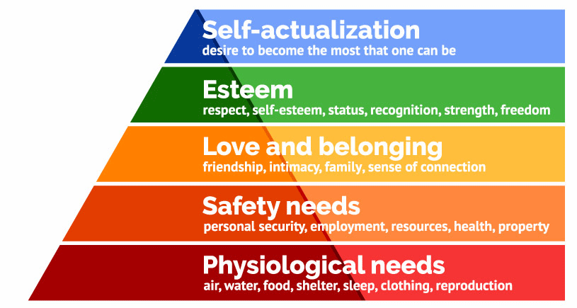

Maslow Model of Hierarchy Needs (Simply Psychology, 2018). Looking into whether we could represent the user data in a way that suited our own ideas we drew an end to exploring this model as it a complex model for user input. We did explore the idea of robitising a small community of robots that used the individual strata of needs to operated but  the module timescale meant we dropped the idea. This early research stage led the team towards a personality model. We uncovered a model that used the acronym CANOE which stood for what is referred to as the “big five”.This model is known as Five Factor Model (FFM).

The five characteristics are:

* Openness
* Conscientiousness
* Extraversion
* Agreeableness
* Neuroticism

The theory is based on a lexical hypothesis, which can be segmented into two assumptions;

“The first states that those personality characteristics that are important to a group of people will eventually become a part of that group's language. The second follows from the first, stating that more important personality characteristics are more likely to be encoded into language as a single word”.(En.wikipedia.org, 2018)

After exploring the idea of of how we could realise the an installation that “Not as much explained personality but described traits” to paraphrase the website emaze.com entered data into and researched some online personality tests to see how their results might be translated into an abstract visual.

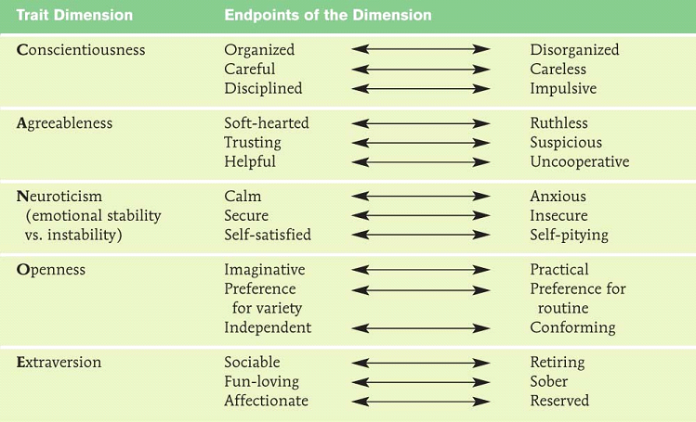

Scaleable CANOE model (emaze presentations, 2018)

Visualisation research

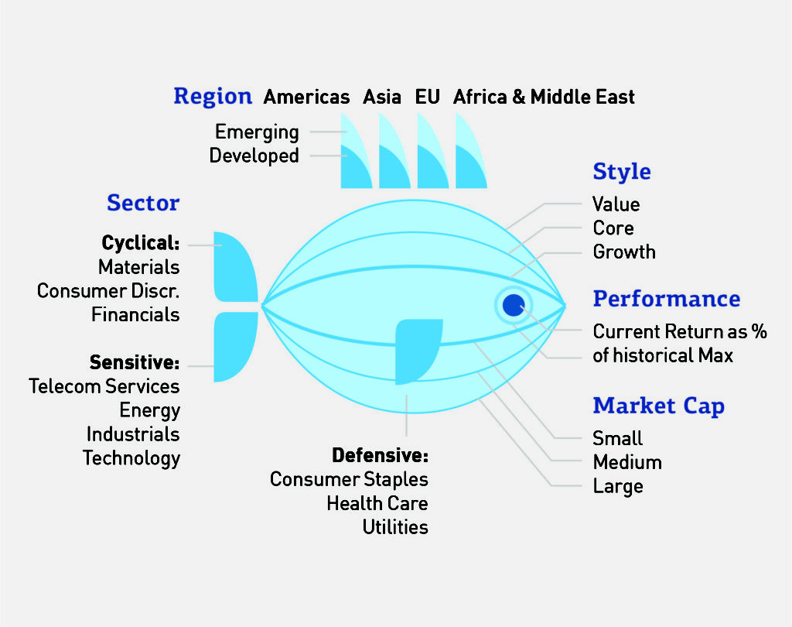

Our inspiration for the visualisation Data personality: evaluation. (Information Age, 2018)

References:

Simply Psychology. (2018). Maslow's Hierarchy of Needs. [online] Available at: https://www.simplypsychology.org/maslow.html [Accessed 18 Jan. 2018].

En.wikipedia.org. (2018). Big Five personality traits. [online] Available at: https://en.wikipedia.org/wiki/Big_Five_personality_traits [Accessed 18 Jan. 2018].

emaze presentations. (2018). Big five factors. [online] Available at: https://www.emaze.com/@AIFIZTTQ/Big-five-factors [Accessed 18 Jan. 2018].

En.wikipedia.org. (2018). Lexical hypothesis. [online] Available at: https://en.wikipedia.org/wiki/Lexical_hypothesis [Accessed 18 Jan. 2018].

Information Age. (2018). Data with personality: the evolution of visualisation. [online] Available at: http://www.information-age.com/data-personality-evolution-visualisation-123464800/ [Accessed 18 Jan. 2018].

Methodology

Methodology (the development practice and structure that was followed to make this project. Any specific techniques or technologies used should be mentioned here). [300 words]

The origin of our project was to explore the idea of personality and how that could be represented using technology and software, after dropping the idea of robots chose to work with a visual media.

Head And Base (Chris)

The Interface base (head mount) was designed on  CAD and laser cut from 3mm & 6mm Mediate board,assembled with wood glues and painted.This was built primarily to hold the raspberry Pi but later was developed as part of the installation.

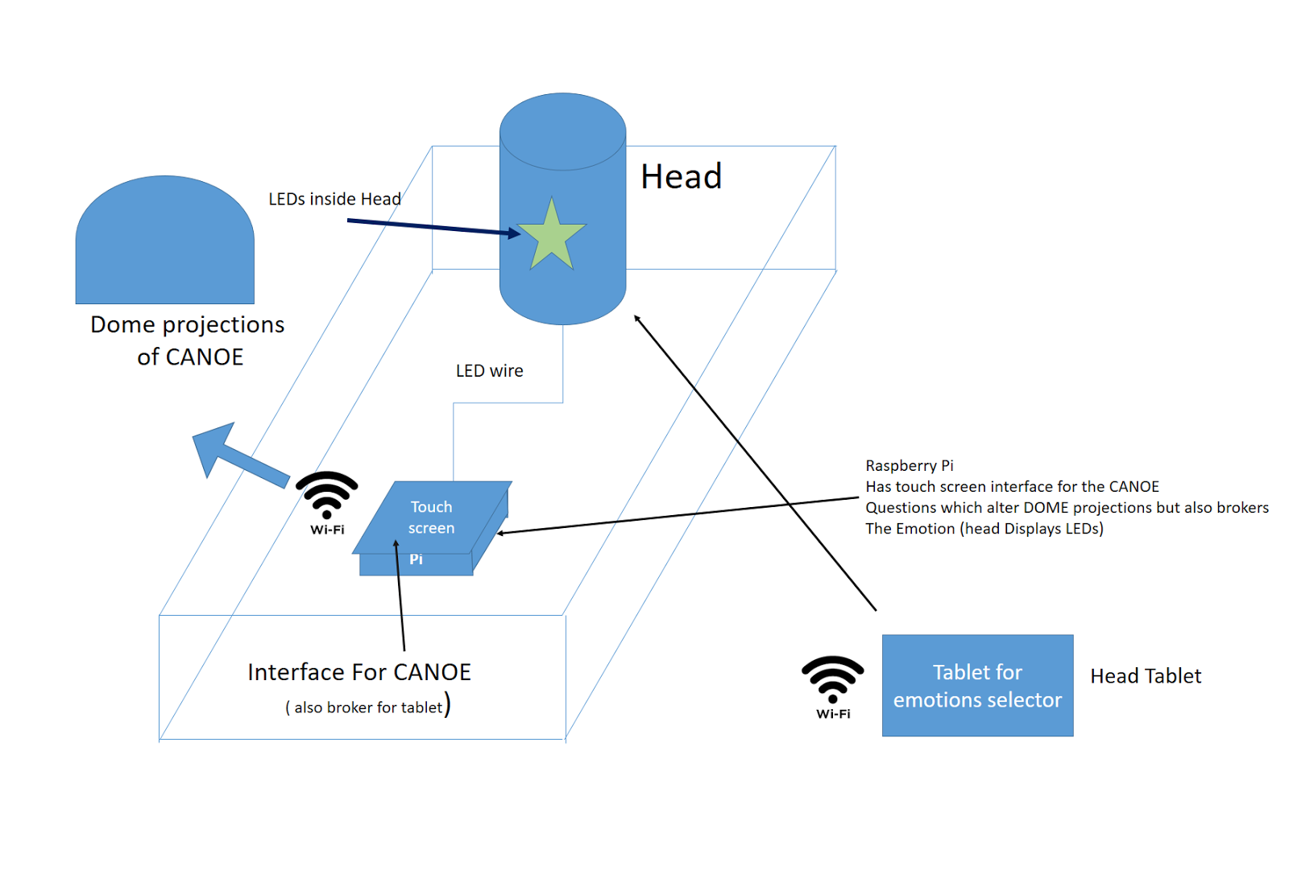

System diagram of Installation (Chris Maycock)

After prototyping 3 leds  from an Arduino Uno inside the glass head, as a lighted feature, two changes were made. By constructing a diffuser to go inside the head the LED light was less obtrusive and also that greater light was needed  to make the feature effective. After fixing a Neopixel 24 LED inside the base the desired result was achieved of multi light effects to draw users to the interface.

HC-05 Bluetooth Module was married to Arduino Uno that drove the Adafruit 24 RGB Neopixel LED Ring to offer colour changes inside the head. A simple console app on my phone was used to set the LED ring stae. A light diffuser was designed and drawn via CAD and 3D printed to diffuse the intense lights inside the glass head.

Back End (Steph)

Before we switched to using abstract shapes; I built a basic visualisation using HTML/CSS/JS of a butterfly with flapping wings.

I originally set up the glass head with an arduino using a serial connection (written in python) with a single LED. After installing the necessary drivers for the Raspberry Pi touchscreen, I programmed a slider using TKinter library for python to output values across the serial connection. We later made several modifications to this, such as replacing the serial connection with bluetooth and switching out the single LED for an RGB LED ring, which I worked on with Chris.

Whilst creating our database connections, we switched between different database types.

Part way through, we decided to switch from MongoDB to mySQL because of difficulties connecting the visualisation to mLab. I set up a database on my remote server temporarily - originally this was intended to be a MongoDB database, but due to incompatibilities with the server software we switched to mySQL. To fulfill the ‘cutting-edge’ technologies requirement of the brief, we later switched back to using MongoDB and mLabs.

We will project this in the IVT, as it fills your vision much like how your personality and emotion affects how you see the world around you.

Animation (Gintare)

Creating slider interface in HTML/CSS .etc

For animation we used p5.js. It is a JavaScript library which is very similar to Processing the main difference between the two is that p5.js works on the website instead of just in a software. I had some previous experience working with Processing since they both work on the same principles it was not that hard to learn a new library. As for the animation itself I took some code from the codepen.io and done some tweaking in order to get the desired result. We wanted to create organic shapes that would be altered with range sliders.

Why p5.js… what code… why

Analysis/Discussion of Results

Analysis / Discussion of Results (provide a critical analysis of your work, so as to explain what works and what doesn’t, what needs to be adjusted or needs to be done in a future update. [200 words]

Conclusion

Conclusion (Recap all previous content, summarize, explain what is the main outcome of this work, and close the report) [100 - 150 words]

References

References section (include all references here – 10 to 20)

**Code**

Neo Pixel reference code

Created April 22, 2015

Hammad Tariq, Incubator (Pakistan)

<https://codepen.io/seanstopnik/pen/CeLqA>

<https://codepen.io/p5art/pen/PqpwgO>

Simply Psychology. (2018). Maslow's Hierarchy of Needs. [online] Available at: https://www.simplypsychology.org/maslow.html [Accessed 18 Jan. 2018].

En.wikipedia.org. (2018). Big Five personality traits. [online] Available at: https://en.wikipedia.org/wiki/Big_Five_personality_traits [Accessed 18 Jan. 2018].

emaze presentations. (2018). Big five factors. [online] Available at: https://www.emaze.com/@AIFIZTTQ/Big-five-factors [Accessed 18 Jan. 2018].

En.wikipedia.org. (2018). Lexical hypothesis. [online] Available at: https://en.wikipedia.org/wiki/Lexical_hypothesis [Accessed 18 Jan. 2018].

Information Age. (2018). Data with personality: the evolution of visualisation. [online] Available at: http://www.information-age.com/data-personality-evolution-visualisation-123464800/ [Accessed 18 Jan. 2018].

**Books and Online**

Annotated Bibliography

Annotated Bibliography section (all books you have reviewed for this project)

Appendix

Appendix section – here you are asked to provide the following:

1.     Project development related content, such as time- planning, budget analysis, description of resources used

Chris

|  |  |  |
| --- | --- | --- |
| **Item** | **Costs** | **Reason for acquisition** |
| 3 & 6mm Medite board and battens | £15 | To construct base to hold Raspberry Pi and glass head |
| Arduino Uno | free | To drive LED effects |
| Bluetooth HC-05 board | £7.99 | To remotely control LEDs |
| Adafruit 24 RGB Neopixel LED Ring | £19.99 | LED display for the Glass Head |
| Unisex Glass Display Vintage Head | £14.99 | Part of the base installation |
| Wood Glue | £3.99 | To fix base together |
| Clear filament | £24.99 | 3D model making of the light diffuser |
| TOTALS                                       £86.95 | |  |

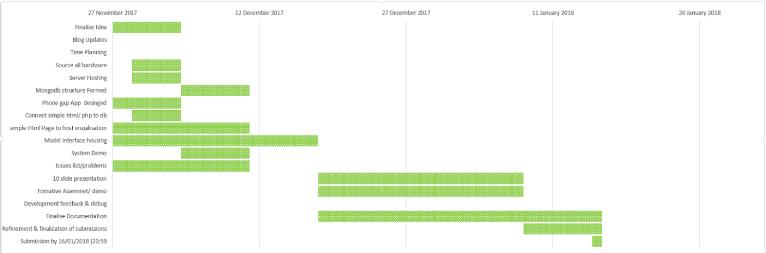

Gantt Timetable prior to new deadline

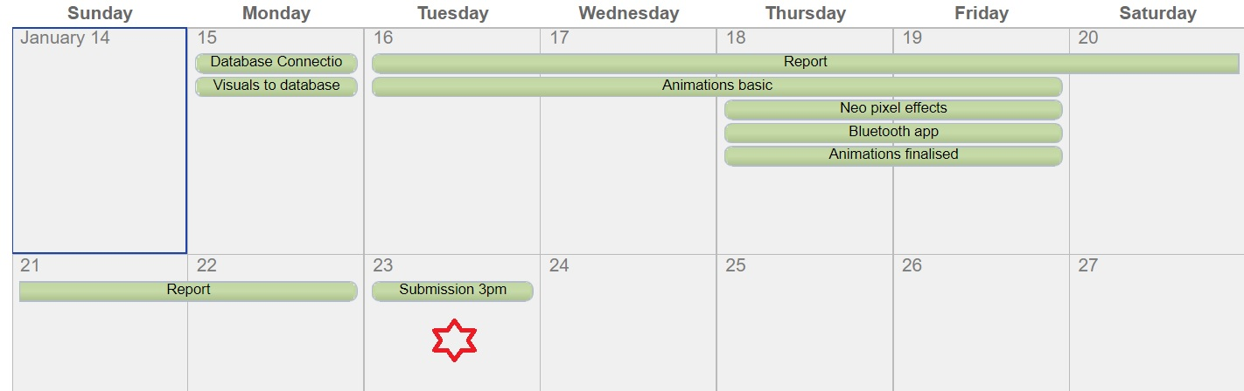

Revised deadline timetable.

|  |  |
| --- | --- |
| Resource Used | Description |
| Arduino Uno | microcontroller board based on the ATmega328P |
| DSD TECH HC-05 Bluetooth Serial Pass-through Module | The core module from the module using the HC-05 , leads interface includes VCC, GND, TXD, RXD, KEY pin , pin-out Bluetooth connection status (STATE), not connected to the output low , after connecting the output high  led indicate Bluetooth connection status , |
|  |  |

2.     Photo documentation of your projects.

Chris photo documentation of the project.

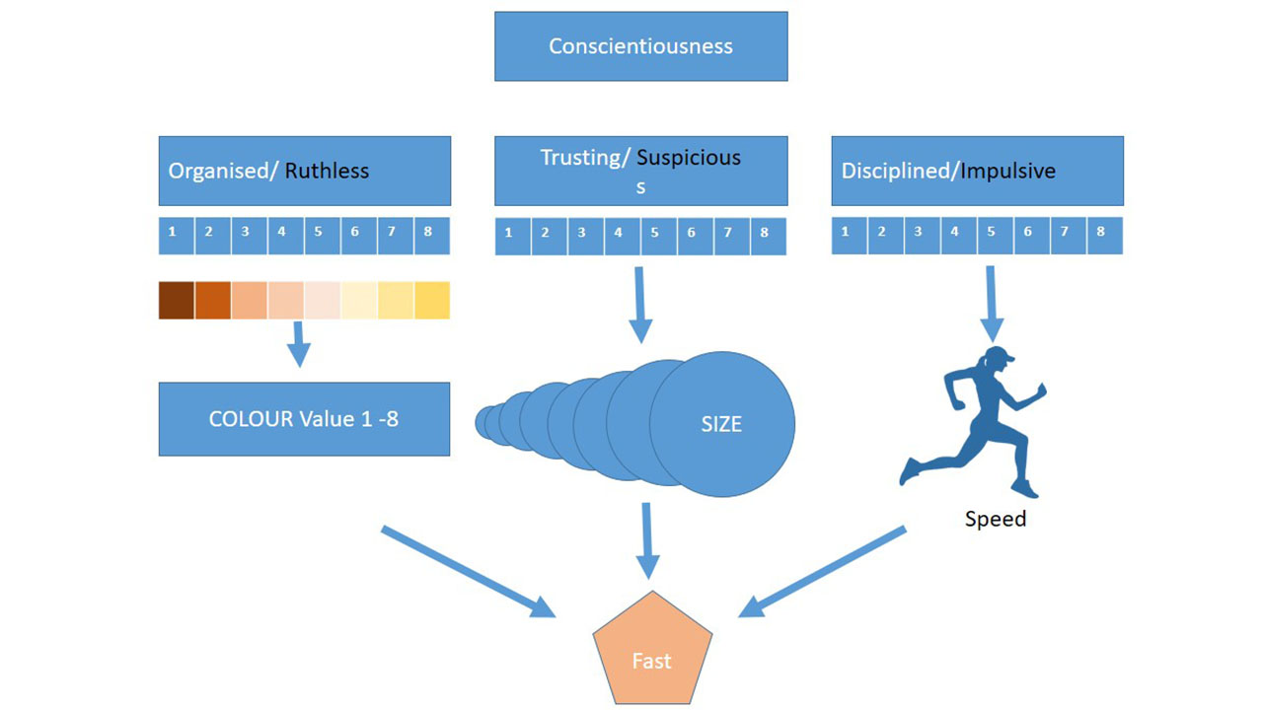

Developing the visualisation through values and parameters System 1a.

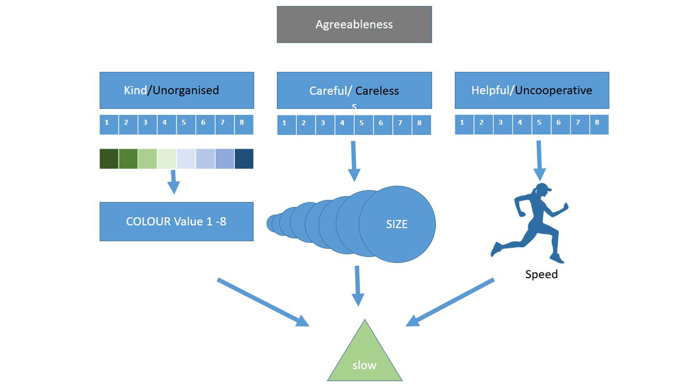

Developing the visualisation through values and parameters System 1b.

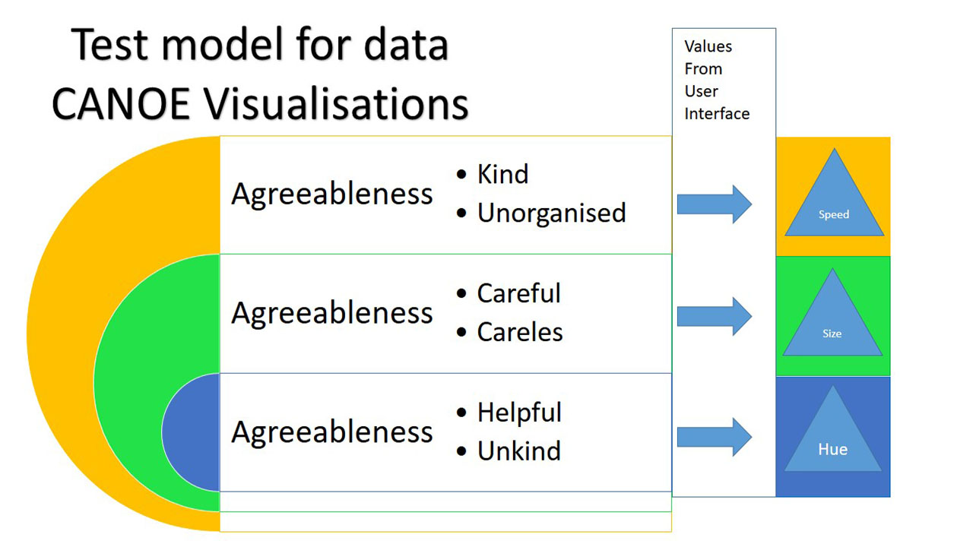

Developing the visualisation through values and parameters System 2.

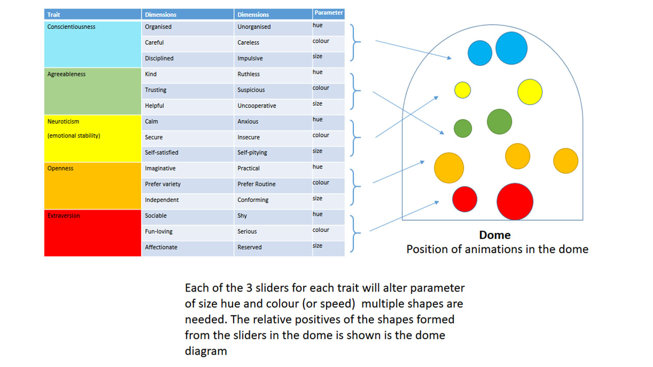

System idea for projecting visualisation spacila inside the dome environment.

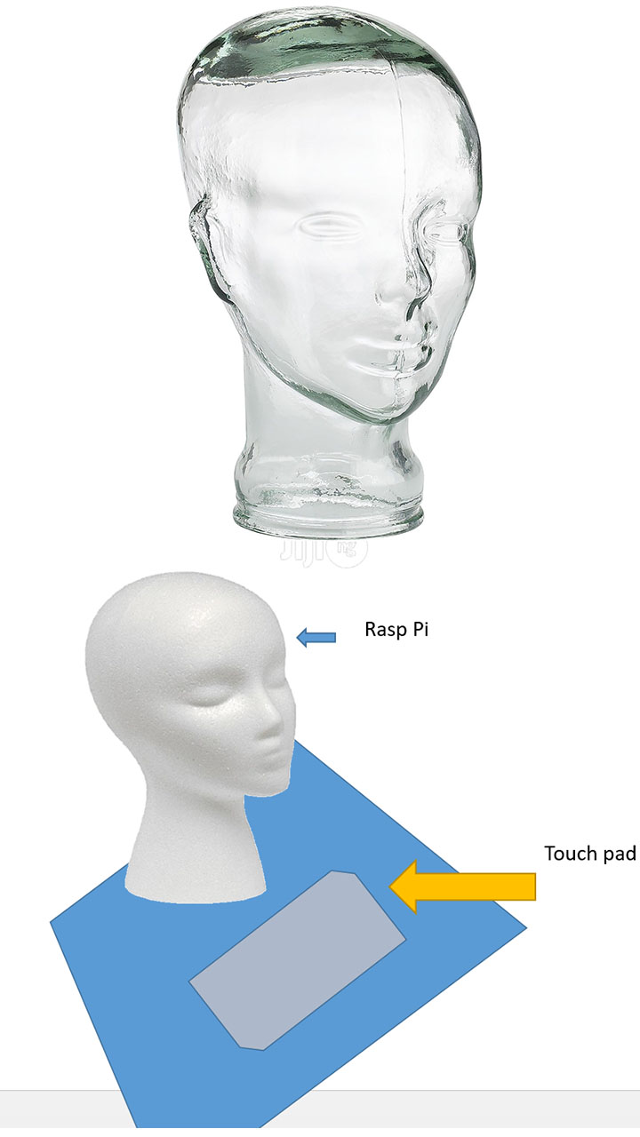

Mock up of  User interface box

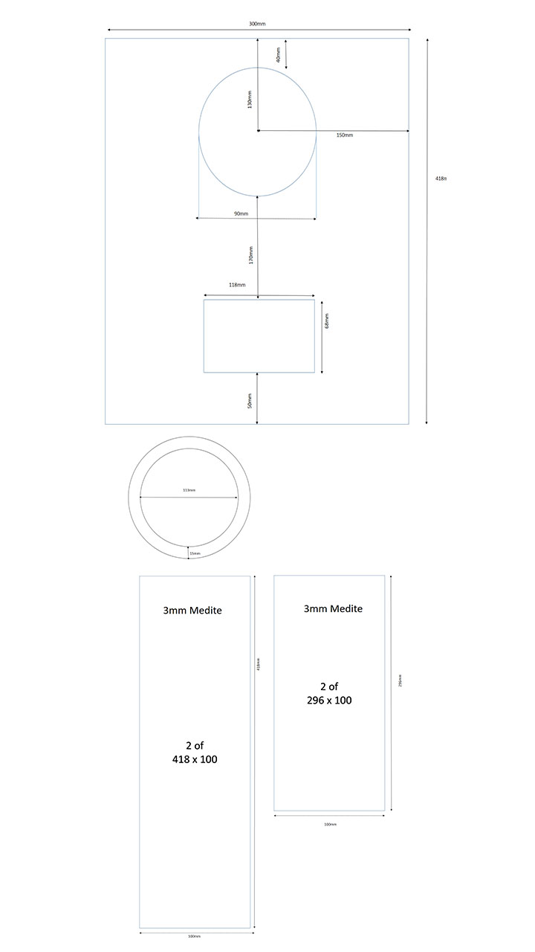

Drawing out the base to be constructed from Mediate.

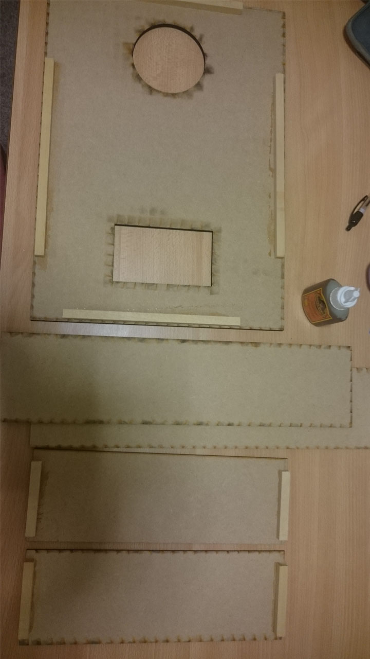

Beginning the Construction of the Base to hold the Head and the Raspberry Pi

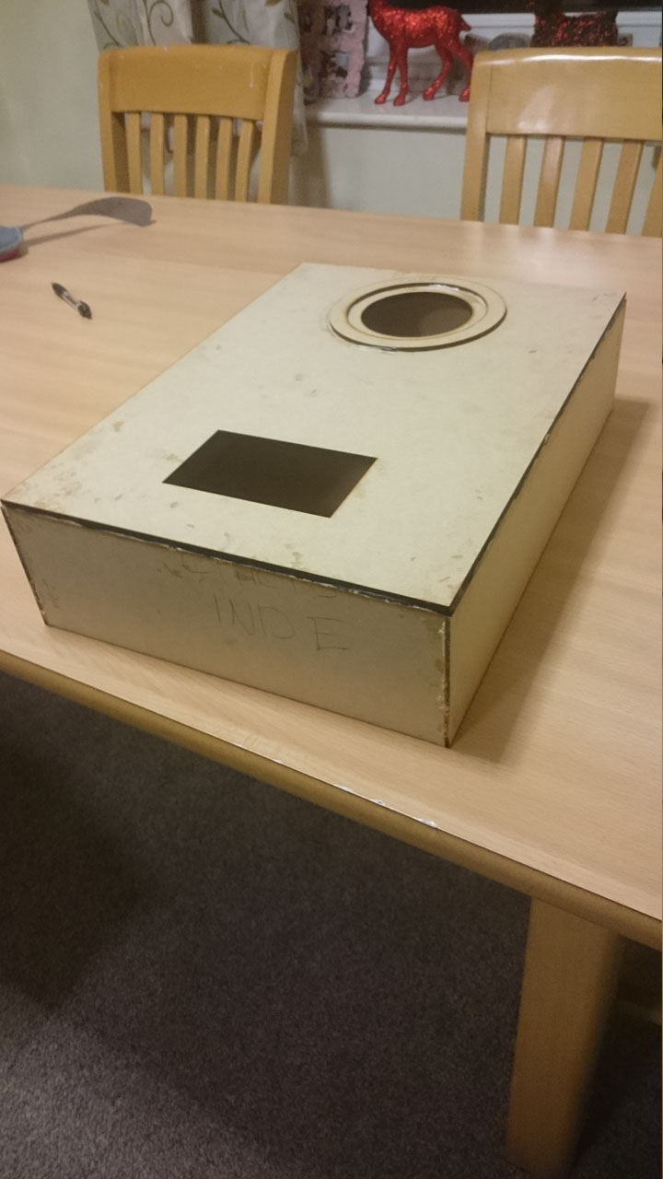

Construction of the Base completed as solid one piece structure

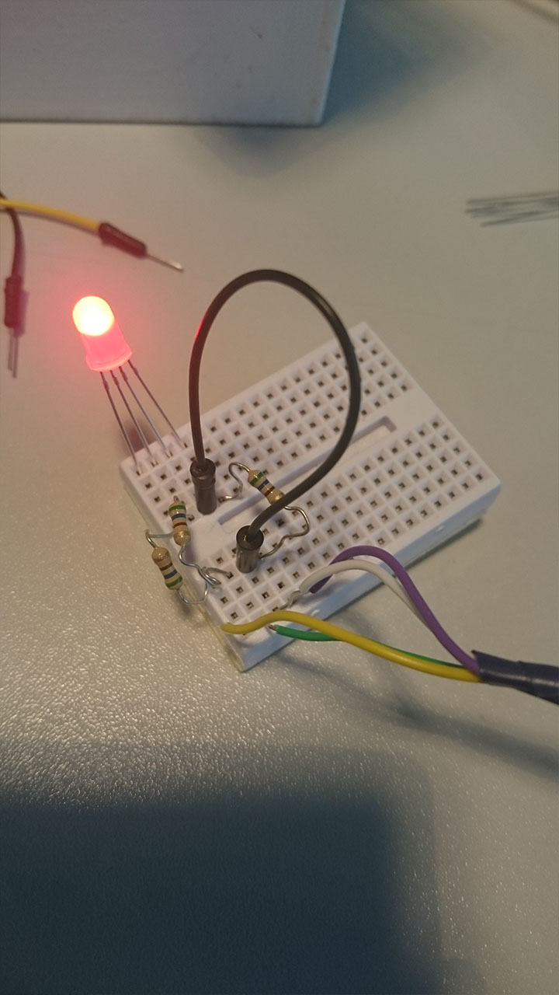

Test LED to prototype illumination of the Head

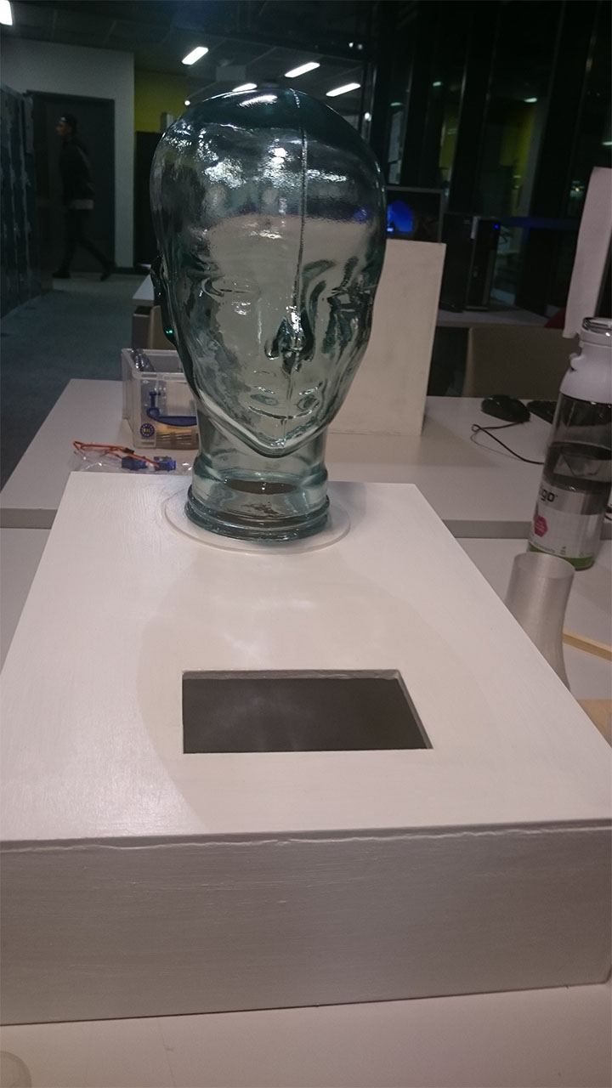

Base and Head married together

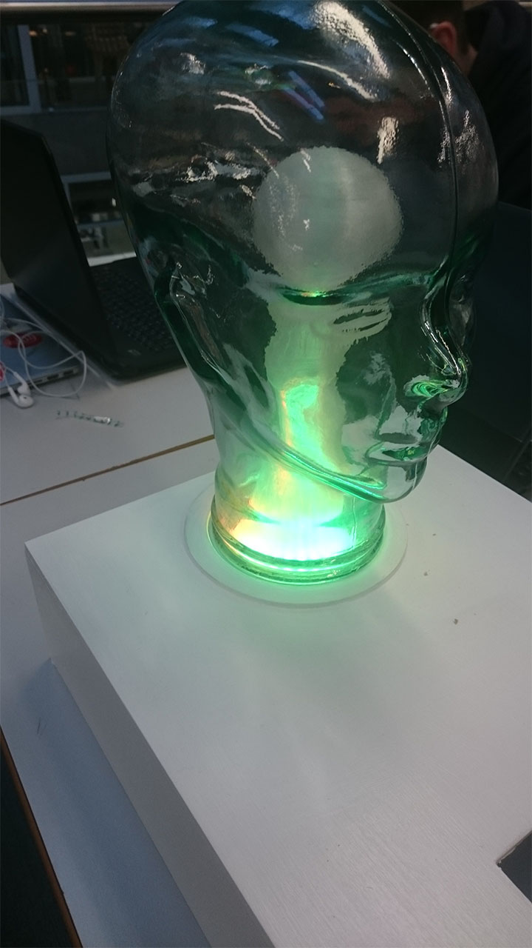

Illuminated head with Neo Pixel 24 LED and self designed Light diffuser.

3.     Break down of duties and responsibilities amongst team members (if this is an individual project, then there is no need)

**Project Breakdown of responsibilities**

**Group Lead**

Chris - Booking group meetings, mediating between team and Tutor, arranging tutorial support on technical issues, drafting the report, design and updating schedules, budget for build

**Research Background**

Chris -   The duties included researching how a persona might be used to generate data to use form the project and the background research for the project

**System diagrams and design**

Steph’ and Chris – Shared  diagram generations and negotiations such as Mongo DB document systems and working systems diagrams

**Animation systems**

Chris – Duties included designing an working through the theoretical systems on how animations may work

**Animations**

Gintare and Chris – duties including working together to design visualisations of data, Gintare coding in p5.js

**Animation Codes**

Gintare – duties included writing the code and testing within the dome.

**Data Base and Back end**

Steph’- enable entire read write to and from database, enable data entry to write the the animations code (with Gintare).

**User Interfacing**

Design – Chris, Code Gintare, Data Steph’.

**Physical interface build and Design**

Chris/ Steph’-  CAD, laser cutting, physical build and finishing, LED ring code and build Steph.­

4.     Any additional related links for your work (final website, blog links, GitHub links, etc)

**Also include**

b.     A folder with digital photos of your sketches and designs that demonstrate your development process (minimum of 10 photos, in high-quality JPEG format, 72dpi, resolution of 1280x720px or 720x1280px)

c. A folder with digital photos and screenshots that display your final work/installation/system (minimum of 10 photos, in high quality

JPEG format, 120 dpi, resolution of 1920x1080px or

1080x1920px)

d.     A folder that contains all related code used for this work, including dependencies, libraries, media files, and so on. Make sure that you include instructions to explain functionality (README file), and that all code has been documented thoroughly.

2) All code files that you have used for this project (i.e. HTML, CSS, Javascript, and so on), have to be submitted in addition as individual text files. Thus, for example if there is any code written in a JS file, you need to submit a TXT file version and submit it individually on DLE. Repeat for all files that include code that you have developed for this work.

3) If there are any outputs related to large media content (i.e. video or sound work), you will have to copy them in a USB stick and submit them to the Students Office (RLB109) before the deadline.

4) All projects need to have their individual GitHub link. All team members need to demonstrate that they have participated in the development of the GitHub project, either by coding, upload of media and design content, documentation, and so on. Optionally, you may have a project website as well. Project links need to be submitted here as an individual TXT file.